Temukan kesalahan grammar pada kalimat berikutini dan kenapa itu salah?

1. I buy this books last month, and all of them is great.

= I **bought** **these** books last month, and all of them **is** great.

* Bought = Karna lampau past tense
* Is = bukan were, jika were maka sudah tidak bgs lagi

1. Why are you laugh? That not funny. Stopping it!

= Why are you **laughing**? **That’s** not funny. **Stop** it!

* Launghing = karna sedang terjadi
* That’s = harus pakai to be
* Stop = kata perintah pakai V1

1. Is Sarah your girlfriend? I see him with another guy at Grand Indonesia yesterday. I have so many informations about her to tell you.

= Is Sarah your gf? I **saw** her with another guy at Grand Indonesia yesterday. I have so **much** informations about her to tell you.

* Saw = karna lampau past tense
* Much = karna uncountable

1. I’m at Jco Yesterday, I’m there just by myself. It’s fun.

= I **was** at Jco yesterday, I **was** there just by myself. It **was** fun.

1. Jimmy and Anna were in my house this morning. I didn’t see they there.

= Jimmy and Anna were in my house this morning. I didn’t see **them** there.

* Them = Kembali ke mereka Jimmy dan Anna

1. I don’t like too many sugars in my coffee, I don’t like sweet stuffs. Ew!

= I don’t like too **much sugar** in my coffee, I don’t like sweet **stuff**. Ew!

* Much = uncountable
* Sugar = tanpa S karna tidak boleh uncountable pakai S
* Stuff = hal-hal tidak boleh ada tambahan S

1. I really need many money, I want to buy a Tesla cars. It’s my dream car.

= I really need **more** money, I want to buy **a** Tesla car. Its’s my dream car.

1. I haven’t talk about our plan to Chintya, maybe tomorrow. I’m so busy lately.

= I haven’t talked about our plan to Chintya, maybe tomorrow. I **have been** so busy lately.

1. Dude, I love the Movie Series “Stranger Things” I watched it since two weeks ago.

= Dude, I love the Movie Series “Stranger Things” I **have watched** it since two weeks ago.

1. Hey, I think I need to eat some foods right now, I was so hungry. See you tomorrow.

= Hey, I think I need to eat some **food** right now, I **am** so hungry. See you tomorrow.

**-ed vs -ing**

Beberapa adjective ada yang brakhiran -ed ada juga yang berakhiran -ing.

Seperti kalimat berikut ini:

📌 The story is boring. I am bored now.

📌 I am very tired. It was a tiring day.

.

.

Kalau kita amati,

-ed digunakan untuk menyatakan perasaan atau apa yang kita rasakan terhadap suatu hal.

Jadi, hal yang dari luar mempengaruhi kita sehingga menimbulkan perasaan tersebut.

-ing digunakan untuk menyatakan sifat dari suatu benda yang berimbas pada diri kita atau orang lain.

Jadi...,

Kalau kalian merasa bosan, jangan bilang "I am boring". Itu brarti kalian yang membosankan dan udah bikin orang lain jadi bosan.

Kalau kalian bosan, kalian harus bilang " I am bored" karena -ed menyatakan tentang apa yang kita rasakan terhadap suatu hal.

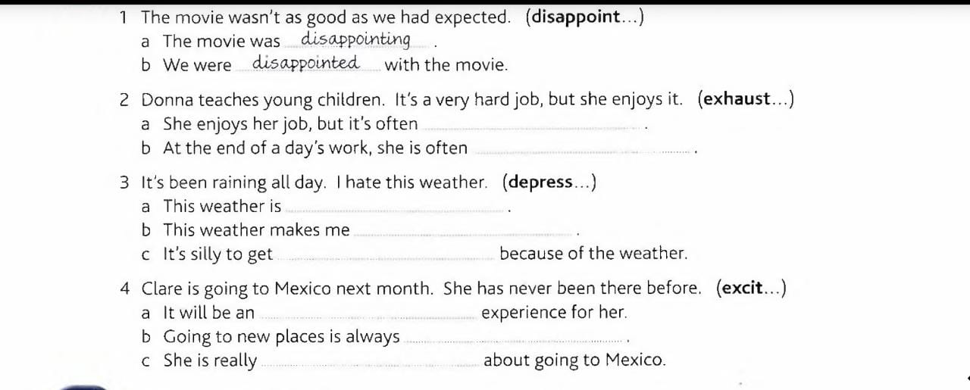

2. Exhausting. Exhausted

3. Depressing. Depressed. Depressed.

4. Exciting. Exciting. Excited.

**Sekarang kita bahas a/an Dan the**

Nah, ini contohnya.

I bought a new book last week. The book is on the table

Kenapa pake a dan the?

= THe itu krn uda jelas buku yg sedang sedang di bahas , buku yg di beli mgg lalu

Contoh lain ya,

Apa bedanya:

I took an apple from the fridge.

I took the apple from the fridge.

= An apple. Sembarang apel. Tp cuman 1 apel.

The apple. Fokusnya ke apel. Mungkin ada buah atau makanan lain tp yg dipilih apel.

Oh iya, ini sedikit tambahan.

Berikut fungsi lain dari THE:

1. Untuk hal yang cuma 1 aja. Kayak The sun, the earth, the president.

2. Ketika kita yakin bahwa orang yang kita ajak ngomong ini paham benda atau orang mana yang kita maksud. Kayak have you seen the cat? Mereka saling paham kucing yang mana yang dimaksud.

3. Untuk alat musik kayak the piano, the guitar, dll.

Cindy recommended **A** good dentist, but **The** dentist doesn't have any openings for two months.

Honey, where's **the** vacuum? I can't find it. It was in **the** closet, but now it's not there.

I was in **a** Japanese restaurant.

**The** restaurant served good food.